Charles Yang

English 250H TE

Mrs. McKenny

10/25/19

Bouldering

Have you ever watched a world championship bouldering competition? If you haven’t, consider making a quick YouTube search. It’s an incredible activity that I’ve found myself addicted to. At the present moment, I can boulder four to five days a week. It’s like a strict training regimen for a varsity sports team. I might commit a whopping twenty hours a week to bouldering.

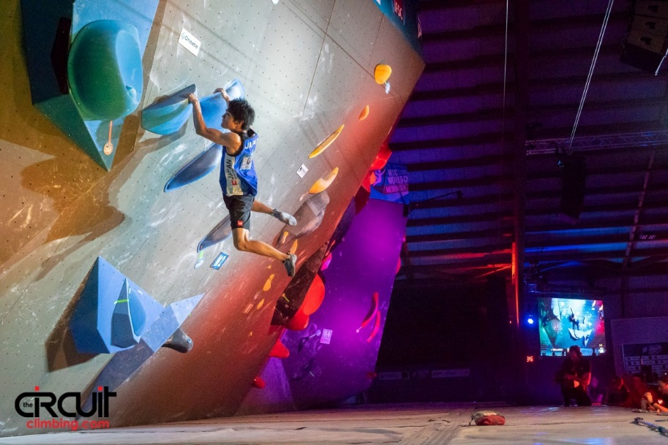 A key component of bouldering is having access to either a crag or climb gym. A crag is a term for an outdoor climbing location on real rock. Since I’m at Iowa State University, I have access to the LIED and State Gym bouldering walls. I personally favor LIED; but I digress. To participate in bouldering, it’s best to have a pair of climbing shoes and a bag of suspicious white powder (chalk). The climbing shoes give you the ability to use the footholds on the wall, as the rubber on the bottom of the shoe has better grip that your everyday trainers. The chalk might not be obvious at first, but it is crucial in any kind of climbing. Your hands will sweat when you’re on the wall. The chalk will keep your hands dry for maximum friction and grip.

Tomoa Narasaki on a five-move jump at the 2018 Meiringen Bouldering World Cup [1]

To understand what bouldering is like completely, you got to know what types of holds are on the wall. The first one is beginner friendly: The Jug. A jug’s defining feature is a spot where your hand can curl inside. Beginner level jugs usually feel like a rough ladder rung, while advanced ones border the line between a flag surface and a jug. The second category of holds include pinches and slopers. Pinches are self-explanatory. The only way to explain slopers, is to say that jugs inspire joy, while slopers do not. They are the opposite of jugs, where it is a sloping surface that is hard to get established on. It’s like the difference between picking up a shallow bowl from the inside and from the outside. You would struggle to pickup the sloped side. The third category of holds are crimps. They are simple, small edges that you usually can’t fit more than a pad of your fingers on the holds.

Climbing is full of technique that can’t be explained in a 600 word essay. But in a nutshell, it involves core intension, coordination, finger and pulling power, and of course endurance. It’s why I love it so much. I started climbing in January when my ex-girlfriend took my climbing on a date. I liked it so much I went back with friends. I kept climbing through the months without any real breaks. The longest I probably went without climbing was one week, when I rode the entirety of RAGBRAI. Now, it is a permanent part of my weekly routine. When needed (which is often), I will go to the bouldering wall to unwind.

Fowke, Eddie. “Recap and Photo Gallery: IFSC 2018 Bouldering World Cup Meiringen.” *Climbing Magazine*, Cruz Bay Publishing, 16 Apr. 2018, www.climbing.com/news/recap-and-photo-gallery-ifsc-2018-bouldering-world-cup-meiringen/.